**Liberia country profile**

Published

22 January 2018

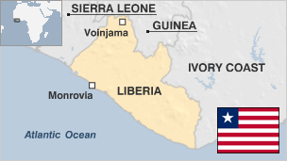

**Liberia is Africa's oldest republic, but it became known in the 1990s for its long-running, ruinous civil war and its role in a rebellion in neighbouring Sierra Leone.**

Although founded by freed American and Caribbean slaves, Liberia is mostly inhabited by indigenous Africans, with the slaves' descendants comprising 5% of the population.

Around 250,000 people were killed in Liberia's civil war, and many thousands more fled the fighting.

Big programmes are under way to address the shortage of electricity and running water. Corruption is rife and unemployment and illiteracy are endemic.

* Read more [country profiles](http://news.bbc.co.uk/1/hi/country_profiles/) - Profiles by [BBC Monitoring](http://bbc.co.uk/monitoring)

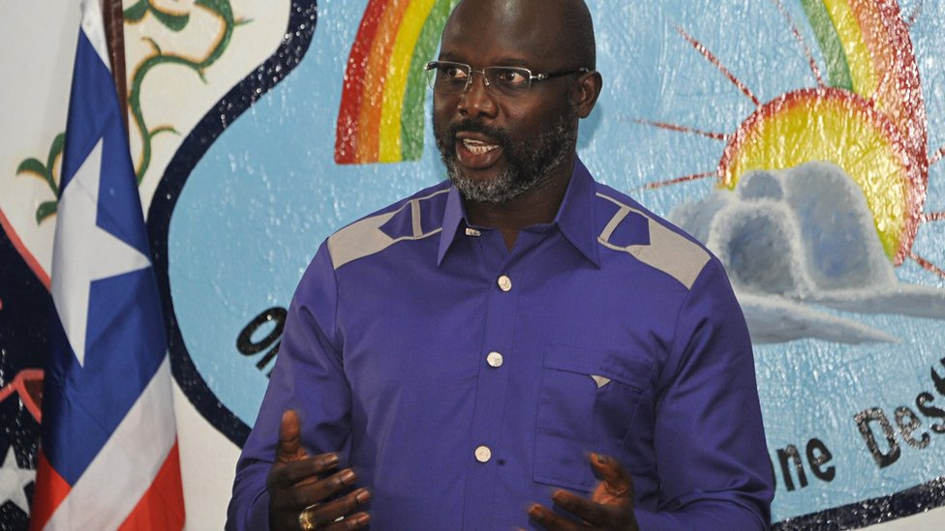image copyrightGetty Images

**President: George Weah**

Former football start George Weah secured a stunning run-off victory in December 2017 in the country's first democratic transfer of power in decades.

Idolised in Liberia as "Mister George", Mr Weah replaced Ellen Johnson Sirleaf, who became president in 2006.

In his first public comments since his victory, Weah told journalists in Monrovia he aimed to "improve the lives" of Liberians.

Weah, 51 at the time of his election, starred in top-flight football at Paris Saint-Germain and AC Milan in the 1990s and briefly at Chelsea and Manchester City before entering politics in 2002.

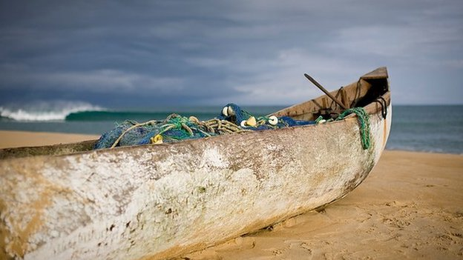image copyrightGlenna Gordon

image captionLiberia has a spectacular coastline, as adventurous surfers are beginning to discover

Liberia's media scene includes private and state outlets. Radio is the main news source and there is a lively commercial sector.

There is real media freedom, says watchdog Reporters Without Borders.

# Liberia profile - Timeline

Published

22 January 2018

## A chronology of key events:

**1847** - Constitution modelled on that of the US is drawn up.

**1847 July** - Liberia becomes independent.

**1917** - Liberia declares war on Germany, giving the Allies a base in West Africa.

**1926** - Firestone Tyre and Rubber Company opens rubber plantation on land granted by government. Rubber production becomes backbone of economy.

**1936** - Forced-labour practices abolished.

**1943** - William Tubman elected president.

**1944** - Government declares war on the Axis powers.

**1951 May** - Women and indigenous property owners vote in the presidential election for the first time.

**1958** - Racial discrimination outlawed.

**1971** - Tubman dies and is succeeded by William Tolbert Jr.

**1974** - Government accepts aid from the Soviet Union for the first time.

**1978** - Liberia signs trade agreement with the European Economic Community.

**1979** - More than 40 people are killed in riots following a proposed increase in the price of rice.

## Years of instability

**1980** - Master Sergeant Samuel Doe carries out military coup. President Tolbert and 13 of his aides are publicly executed. A People's Redemption Council headed by Doe suspends constitution and assumes full powers.

**1984** - Doe's regime allows return of political parties following pressure from the United States and other creditors.

**1985** - Doe wins presidential election.

**1989** - National Patriotic Front of Liberia (NPFL) led by Charles Taylor begins an uprising against the government.

**1990** - Economic Community of West African States (Ecowas) sends peacekeeping force. Doe is executed by a splinter group of the NPFL.

**1997** - After several years of chaotic, stop-go fighting, Taylor wins a presidential election. International observers declare the elections free and fair.

## Border fighting

**1999 January** - Ghana and Nigeria accuse Liberia of supporting Revolutionary United Front rebels in Sierra Leone. Britain and the US threaten to suspend aid to Liberia.

**2000** July - Stability remains elusive. Government reports first attacks by rebels who identify themselves as Liberians United for Reconciliation and Democracy (LURD).

**2001** May - UN Security Council reimposes arms embargo to punish Taylor for trading weapons for diamonds from rebels in Sierra Leone.

**2002** January - More than 50,000 Liberians and Sierra Leonean refugees flee fighting. In February Taylor declares a state of emergency.

## Rebel offensives

**2003** March - Rebels advance to within 10km of Monrovia.

**2003** June - Talks in Ghana aimed at ending rebellion overshadowed by indictment accusing President Taylor of war crimes over his alleged backing of rebels in Sierra Leone.

**2003** July - Fighting intensifies; rebels battle for control of Monrovia. Several hundred people are killed. West African regional group Ecowas agrees to provide peacekeepers.

## Taylor in exile

**2003** August - Nigerian peacekeepers arrive. Charles Taylor leaves Liberia after handing power to his deputy Moses Blah. US troops arrive. Interim government and rebels sign peace accord. Gyude Bryant chosen to head interim administration.

Rebels hand in their weapons.

**2003** September-October - US forces pull out. UN launches major peacekeeping mission, deploying thousands of troops.

**2004** October - Riots in Monrovia leave 16 people dead; the UN says former combatants were behind the violence.

## Johnson Sirleaf elected

**2005 23** November - Ellen Johnson Sirleaf becomes the first woman to be elected as an African head of state.

**2006** February - Truth and Reconciliation Commission is set up to investigate human rights abuses between 1979 and 2003.

**2006** April - Former president Charles Taylor appears before a UN-backed court in Sierra Leone on charges of crimes against humanity. In June the Netherlands-based International Criminal Court agrees to host his trial.

**2006** June - UN Security Council eases a ban on weapons sales so Liberia can arm newly trained security forces. An embargo on Liberian timber exports is lifted shortly afterwards.

**2006** July - President Johnson Sirleaf switches on generator-powered street lights in the capital, which has been without electricity for 15 years.

**2007** April - UN Security Council lifts its ban on Liberian diamond exports. The ban was imposed in 2001 to stem the flow of "blood diamonds", which helped to fund the civil war.

**2007** May - UN urges Liberia to outlaw trial by ordeal.

## Taylor on trial

**2007** June - Start of Charles Taylor's war crimes trial in The Hague, where he stands accused of instigating atrocities in Sierra Leone.

**2008** January - Supreme Court rules that the president can appoint local mayors because the government cannot afford to hold municipal elections. Municipal elections have not been held since 1985 because of financial constraints and successive civil wars.

**2008** February - US President George W Bush ends a five-country tour of Africa with a visit to Liberia, one of America's staunchest allies on the continent.

**2008** March - Liberia conducts its first census since 1984.

**2009** February - President Johnson Sirleaf admits to Truth and Reconciliation Commission that she mistakenly backed ex-President Charles Taylor when he launched the 14-year civil war in 1989.

**2009** July - Truth Commission submits report to parliament, recommends prosecuting 200 people and listing others who should be barred from public office, including President Johnson Sirleaf.

**2009** September - UN Security Council votes to extend mandate of UN forces in Liberia (UNMIL) into 2010 to help with 2011 elections.

## Religious tension

**2010** February - Fighting erupts between Christians and Muslims in northern province of Lofa after the killing of a Christian student. Several churches and mosques are destroyed.

**2010** June - IMF, World Bank devise plan to relieve Liberia of heavy debt burden.

**2010** September - The 19-nation Paris Club of creditor countries pardon $1.2bn worth of debt owed by Liberia.

**2010** November - President Johnson Sirleaf dismisses cabinet, reportedly to start with a ''clean slate''.

**2011** April - War crimes trial of former Liberian leader Charles Taylor ends, with a judgment expected to be handed down later in the year.

**2011** October - President Johnson Sirleaf awarded Nobel Peace Prize.

**2011** October-November - Presidential elections. President Johnson Sirleaf wins re-election. Her main rival boycotts the second round.

**2012** February - Energy companies report discovery of oil off the coasts of Liberia and Sierra Leone. Work continues to estimate their size.

**2012** March - George Boley, the former leader of the rebel Liberial Peace Council, is deported to Liberia from the US over his role in the civil war in the 1990s.

**2012** April - Ex-president Charles Taylor is found guilty of war crimes for aiding and directing rebels in Sierra Leone. He is sentenced to 50 years in jail, to be served in Britain.

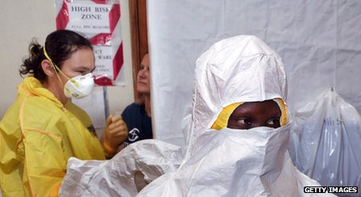image copyrightGetty Images

image captionLiberia was hit hard by the 2014 outbreak of the Ebola virus

**2012** June - Liberia closes its border with Ivory Coast after seven UN peacekeepers are killed on the Ivorian side, by attackers allegedly based in Liberia.

**2012** September - President suspends forestry chief and launches probe into recent timber deals amid concerns of widespread fraud.

**2013** January - UN Refugee Agency completes a programme that helped more than 155 000 Liberians return home, hailing it as evidence of the return of peace after the civil war.

**2013** June - Campaign group Global Witness says half the forest in Liberia is being logged illegally, in spite of government promises to halt such activity.

**Ebola outbreak**

**2014** July-October - Liberia announces emergency measures to combat spread of outbreak of Ebola virus.

World Health Organisation says the spread of Ebola in west Africa is an international public health emergency, and calls for a coordinated response. US President Obama announces 3,000 US military personnel being sent to west Africa to build new health facilities and to train health workers.

**2016** January - UN declares Liberia and the whole of West Africa provisionally free of Ebola. More than 11,000 died of the disease in West Africa since December 2013, 4,809 of them in Liberia.

**2016** June - UN peacekeeping forces in Liberia (UNMIL) hand back responsibility for security to the country's army and police. The mission first deployed in 2003, after two civil wars in which hundreds of thousands of people were killed.

**2017** December - George Weah elected president.